Ethical Hacking
List of Experiments
1. Execute and display the results for the following commands in Kali Linux Operating Systems:
rm command
users command
tree command
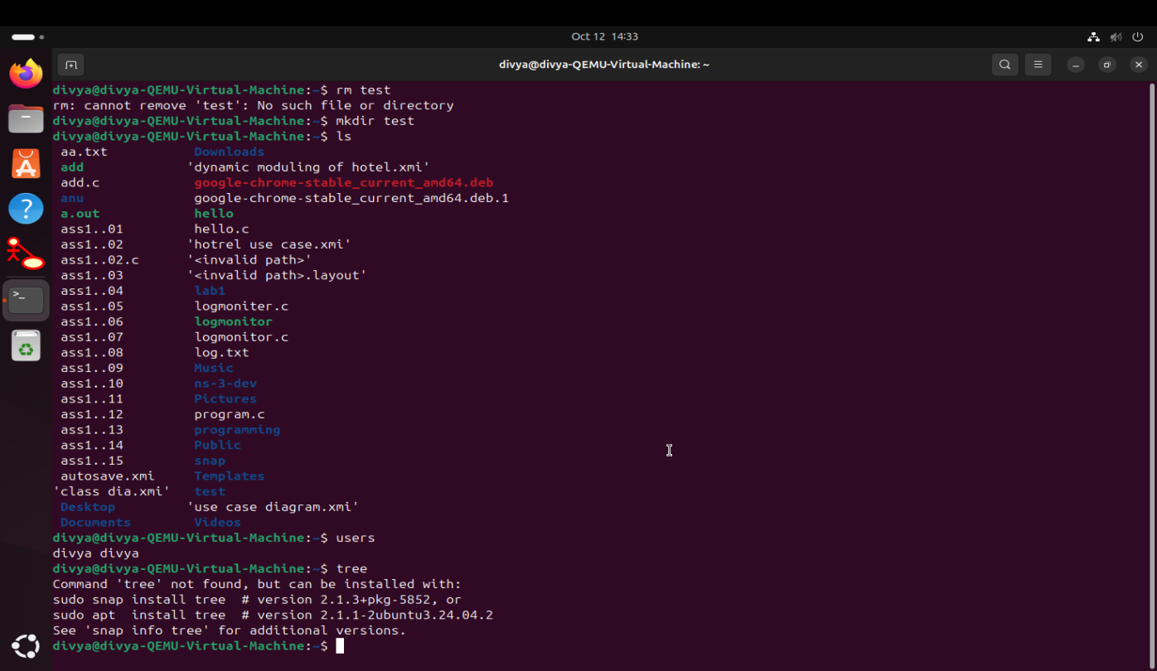
2. Execute and display the results for the following commands in Kali Linux Operating Systems:
less command
more command
vi command
3. Execute and display the results for the following commands in Kali Linux Operating Systems:
Tree
Head
Tail
4. Execute and display the results for the following commands in Kali Linux Operating Systems:
i) Ls
ii) Cat
iii) Mkdir
5. Execute and display the results for the following commands in Kali Linux Operating Systems:
i) Uptime
ii) Date
iii) Mv
6. Execute and display the results for the following commands in Kali Linux Operating Systems:
i) Touch
ii) Pwd
iii) Wget
7. Execute and display the results for the following commands in Kali Linux Operating Systems:
Cd
Cp
ls
8. Execute and display the results for the following Nmap service version and OS detection commands in Kali Linux operating systems:
i) detect the version of services running
ii) aggressive scan
iii) detect operating system of the target
9. Execute and display the results for the following Nmap Timing and performance commands in Kali Linux operating Systems:
(i) polite IDS evasion
(ii) normal IDS evasion
10. To execute the following commands in Kali Linux Operating Systems: Free command
Sort command
History command
11. Execute and display the results for the following Nmap Timing and performance commands in Kali Linux operating Systems:
(i) aggressive speed scan
(ii) insane speed scan
12. Port Scanning Tools
13. Host Discovery
14. Cracking the Password Using Hydra
15. Information Gathering Using theHarvester
16. Use Google & Who.is for Reconnaissance
17. Windows OS Commands Execution (traceroute, ping, ifconfig, netstat) 18. Vulnerabilities Analysis Using CGI Scanning with Nikto
19. Wireshark Sniffer for Network Traffic & Analysis
20. Implement the Boot Sector Virus (msfvenom)
21. Batch File Execution
22. Packet Analyser Tool
23. Port Scanning Tools (Extended)
24. Nmap Timing & Performance
25. Using Shell Programming
i) Read a number and find its square
ii) Find the biggest of three numbers

